I am Esmeralda Kadëna from Albania. I was decided to explore somewhere different, to live away from my country for the first time. I was offered this destination by my sending institution (European University of Tirana) for an Erasmus+ Credit Mobility and applied immediately and it happened. I took the opportunity to do so in Budapest where I knew there was a big student community.
Time went so fast and finally I was at Óbuda University (Keleti Károly - Faculty of Business and Management) to complete the last semester of my MSc. in Business Information Technology. Firstly I thought it will be difficult to work on my thesis but when I met my supervisor everything seemed to be easier.
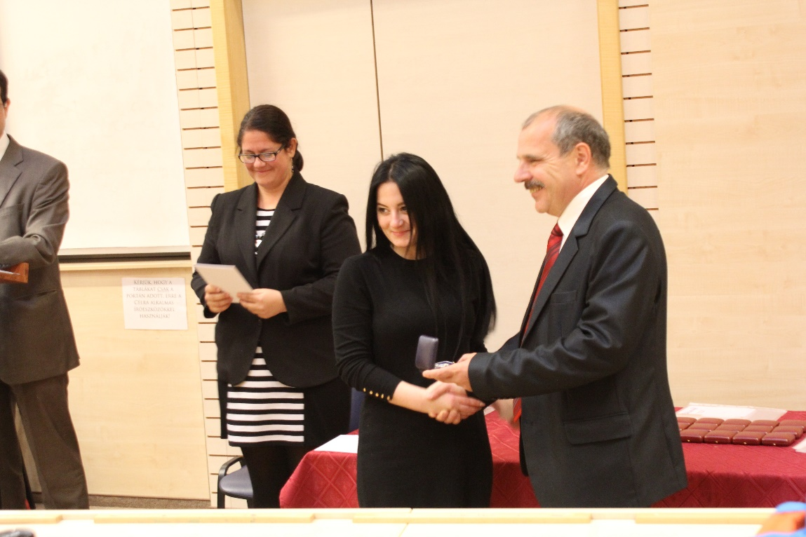
It was a great opportunity to participate in “TDK” (Scientific Conference for Students) which helped me on thesis work and an unexpected prize came to me (handed by the vice-rector for science). I am really thankful to Óbuda and I really appreciate their help, kindness and generosity.

Apart these opportunities for learning, there are many other to enjoy the life in Budapest. The staff of University helped us to be familiar with the city and to know more about it. The best place to meet a lot of international students, you can make new friends, learning from different cultures, different ways of life, improving your English or why not to learn any other language and having a great social life. In the city you can make a lot of tourism, the architecture is great, everywhere you look there is a building with some cool design details. You should see the main places of Budapest, as the Parliament, Buda side with all wonderful things you will find there, St. Stephen's Basilica, Deák Ferenc, Opera, Hero’s Square and the peaceful park behind it, Citadella, Vaci utca, different museums, the thermal baths and so on.
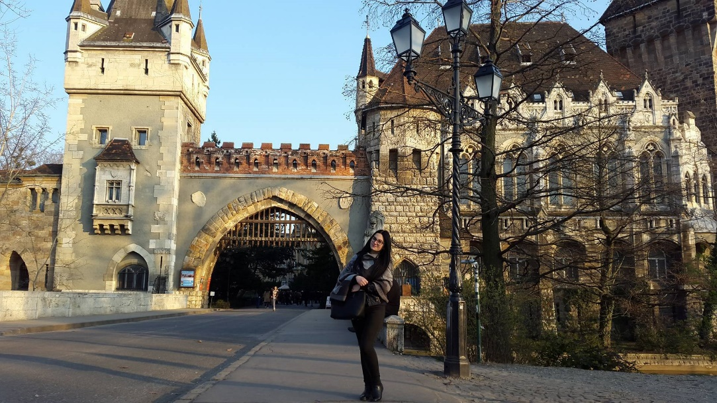

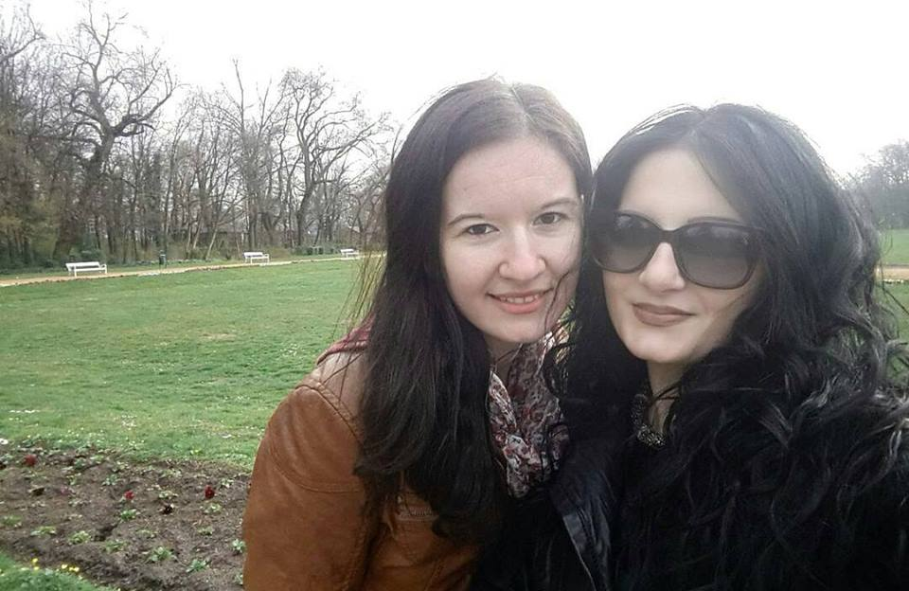

Which is more the Budapest nightlife is exciting. Clubs, bars and ruin pubs are around in Budapest. The reasonable prices as well as public transport make your staying period easier.

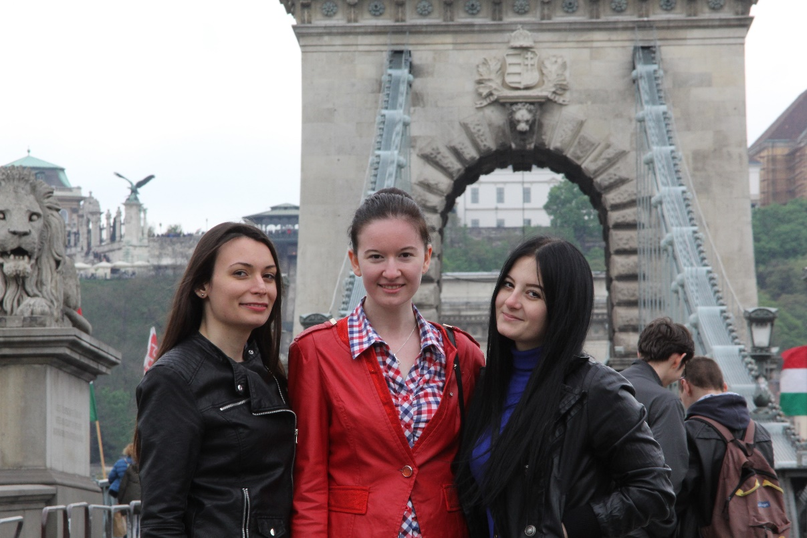

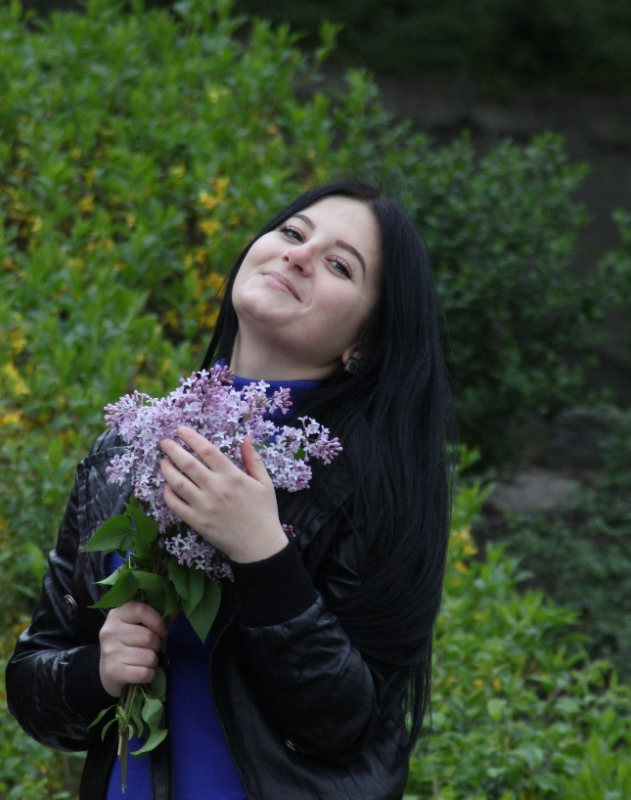
It was a new and an unforgettable experience and I suggest all the students especially those who are from Albania to try it. It’s unique from the personal and academic point of view as well. This 4 months experience was highly enjoyable, exciting and helped me to grow as a person.

